**How to install SonalQube 7.0**

Steps 1

1. Download SonalQube 7.0 from <https://www.sonarqube.org/downloads/>
2. Unzip - let's say in "C:\sonarqube"
3. Start the SonarQube server:

Example :

# On Windows, execute:

C:\sonarqube\bin\windows-x86-xx\StartSonar.bat

1. Log in to [http://localhost:9000](http://localhost:9000/) with System Administrator credentials (admin/admin)
2. Add following sonar maven plugin in your project pom.xml

**<dependency>**

**<groupId>org.codehaus.mojo</groupId>**

**<artifactId>sonar-maven-plugin</artifactId>**

**<version>3.2</version>**

**<type>pom</type>**

**</dependency>**

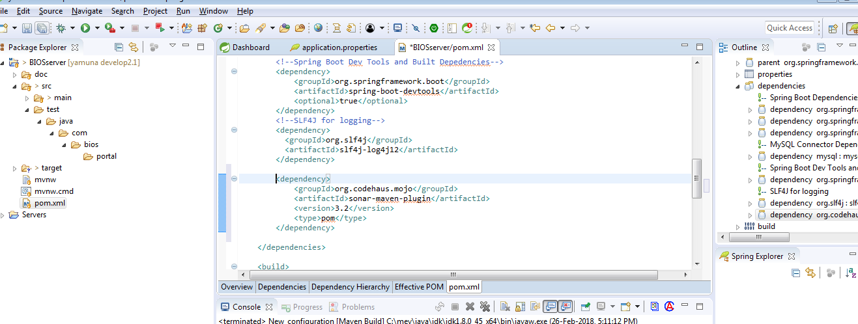

1. Run maven project by given command sonar:sonar

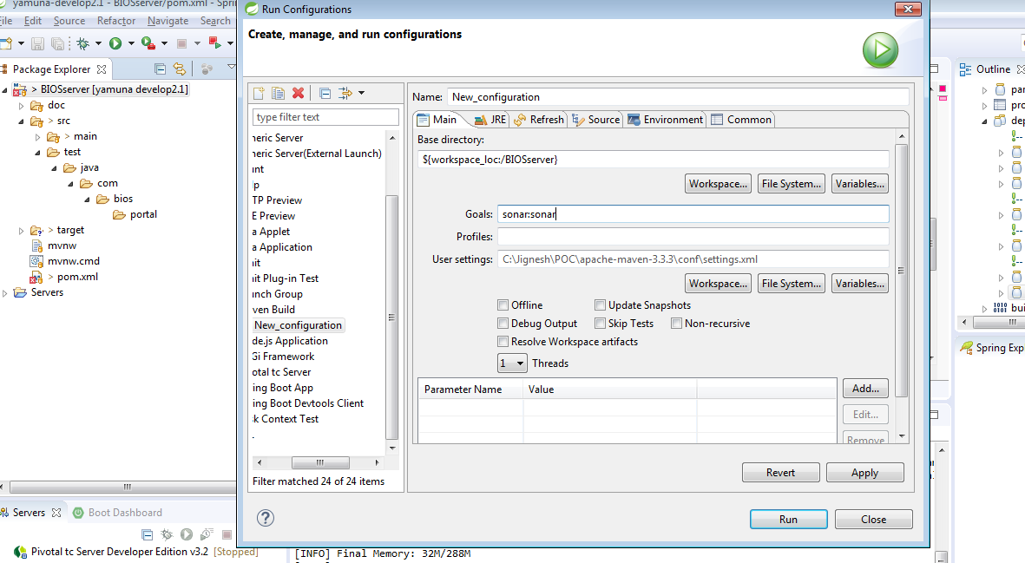

1. Check on Report on Sonar Server <http://localhost:9000/projects>

